**Practical No: 9**

**Practical Title: Program for Two Dimensional Transformation (Reflection)**

**Roll no: Batch: Date of performance:**

#include<stdio.h>

#include<conio.h>

#include<graphics.h>

#include<dos.h>

#include<math.h>

void main()

{

int gd,gm;

int x1=500,y1=120,x2=500,y2=220,x3=430,y3=220,choice;

clrscr();

detectgraph(&gd,&gm);

initgraph(&gd,&gm,"C:\\TC\\BGI");

setbkcolor(15);

setcolor(8);

outtextxy(10,10,"Choose type of Reflection 1- X Axis 2- Y Axis");

scanf("%d",&choice);

outtextxy(350,90,"Original");

line(getmaxx()/2,0,getmaxx()/2,getmaxy());

line(0,getmaxy()/2,getmaxx(),getmaxy()/2);

setcolor(8);

line(x1,y1,x2,y2);

line(x2,y2,x3,y3);

line(x3,y3,x1,y1);

switch(choice)

{

case 1:

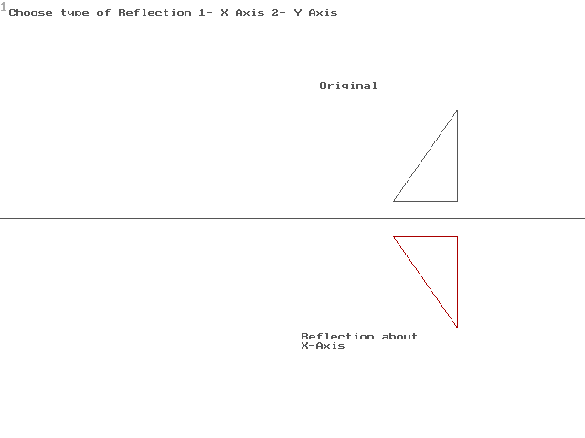 outtextxy(330,365,"Reflection about");

outtextxy(330,375,"X-Axis");

setcolor(4);

line(x1,getmaxy()-y1,x2,getmaxy()-y2);

line(x2,getmaxy()-y2,x3,getmaxy()-y3);

line(x3,getmaxy()-y3,x1,getmaxy()-y1);

break;

case 2:

outtextxy(180,90,"Reflection about");

outtextxy(180,100,"Y Axis");

setcolor(1);

line(getmaxx()-x1,y1,getmaxx()-x2,y2);

line(getmaxx()-x2,y2,getmaxx()-x3,y3);

line(getmaxx()-x3,y3,getmaxx()-x1,y1);

break;

}

getch();

closegraph();

}